**FDEM Chris Stevens found some battery info, some of it is pretty interesting!**

https://www.osha.gov/sites/default/files/publications/shib011819.pdf

https://cfpa-e.eu/container-puts-out-inextinguishable-fires-in-electric-cars/

https://www.wikihow.com/Put-Out-a-Cell-Phone-Fire

https://www.amazon.com/BAT-SAFE-LiPo-Battery-Charging-Painted/dp/B07ZPKKF26/ref=asc_df_B07ZPKKF26/?tag=hyprod-20&linkCode=df0&hvadid=475811497606&hvpos=&hvnetw=g&hvrand=17907847724801809091&hvpone=&hvptwo=&hvqmt=&hvdev=c&hvdvcmdl=&hvlocint=&hvlocphy=9011610&hvtargid=pla-996765110396&psc=1containers used for lithium fire battery fires

https://www.avdfire.com/products/fire-resistant-battery-container/

Electric car fire container

<https://brandogsikring.dk/en/news/2020/container-puts-out-inextinguishable-fires-in-electric-cars/>

*Published 08.03.20*

The lithium-ion batteries in electric and hybrid cars present a challenge to the emergency services if the cars are involved in a traffic accident or burst into flames. Now, the emergency services in Denmark have developed their own solution.

Cars can burst into flames a long time after they have been damaged. They can be exceptionally difficult to extinguish. They can flare up again and again. They emit combustible and harmful gases. Water is contaminated and damaging to the environment due to chemicals. Yes, the batteries in electric and hybrid cars present numerous challenges when you look at it from the point of view of the emergency services. This is the conclusion of a new report from the Swedish organisation RISE, which has taken a closer look at lithium-ion batteries in vehicles. The numerous factors specific to electric and hybrid cars present the emergency services with a number of challenges, which the emergency services in Copenhagen are now tackling. They have designed a container specifically for handling damaged electric and hybrid cars.- We are seeing more and more electric and hybrid cars in the municipalities we cover. And, it would appear that there will be many more in the future. That is why we must be able to deal with the chemical fires they can cause, says Michael Kim Andersen, Deputy Director of Emergency Services in Copenhagen.

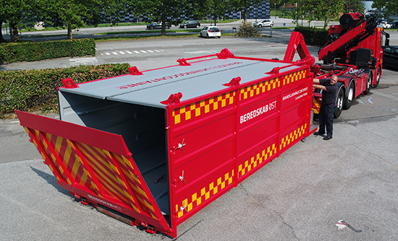

[https://ctif.org/topics/lithium-battery-fires](https://gcc02.safelinks.protection.outlook.com/?url=https%3A%2F%2Fctif.org%2Ftopics%2Flithium-battery-fires&data=05%7C01%7CRobert.Dietrich%40em.myflorida.com%7C32bdcef9c0a74cc7c8c508db475135b6%7C9ce0de61985749a2b40c3a9cb9f8f4dc%7C0%7C0%7C638182186385612070%7CUnknown%7CTWFpbGZsb3d8eyJWIjoiMC4wLjAwMDAiLCJQIjoiV2luMzIiLCJBTiI6Ik1haWwiLCJXVCI6Mn0%3D%7C3000%7C%7C%7C&sdata=MObSFeRXJvvN8zkErbJKMx4La9TFPcw7QndUHmFkNb0%3D&reserved=0)

Lithium battery fires different types and areas.

[https://ctif.org/news/state-virginia-makes-special-ev-fire-risk-assessment-training-mandatory-firefighters](https://gcc02.safelinks.protection.outlook.com/?url=https%3A%2F%2Fctif.org%2Fnews%2Fstate-virginia-makes-special-ev-fire-risk-assessment-training-mandatory-firefighters&data=05%7C01%7CRobert.Dietrich%40em.myflorida.com%7C32bdcef9c0a74cc7c8c508db475135b6%7C9ce0de61985749a2b40c3a9cb9f8f4dc%7C0%7C0%7C638182186385612070%7CUnknown%7CTWFpbGZsb3d8eyJWIjoiMC4wLjAwMDAiLCJQIjoiV2luMzIiLCJBTiI6Ik1haWwiLCJXVCI6Mn0%3D%7C3000%7C%7C%7C&sdata=VtBFLzjsWElB%2BydXIl9Icnj108CK%2FSzBz4vHdeez8UY%3D&reserved=0)

[https://ctif.org/news/new-revolutionary-method-extinguishes-lithium-ion-ev-fires-ten-minutes-minimal-water](https://gcc02.safelinks.protection.outlook.com/?url=https%3A%2F%2Fctif.org%2Fnews%2Fnew-revolutionary-method-extinguishes-lithium-ion-ev-fires-ten-minutes-minimal-water&data=05%7C01%7CRobert.Dietrich%40em.myflorida.com%7C32bdcef9c0a74cc7c8c508db475135b6%7C9ce0de61985749a2b40c3a9cb9f8f4dc%7C0%7C0%7C638182186385612070%7CUnknown%7CTWFpbGZsb3d8eyJWIjoiMC4wLjAwMDAiLCJQIjoiV2luMzIiLCJBTiI6Ik1haWwiLCJXVCI6Mn0%3D%7C3000%7C%7C%7C&sdata=W0TMYY4wyQaOQzZiGUlKtoNWigtFnlLOlBEwwpnSVow%3D&reserved=0)

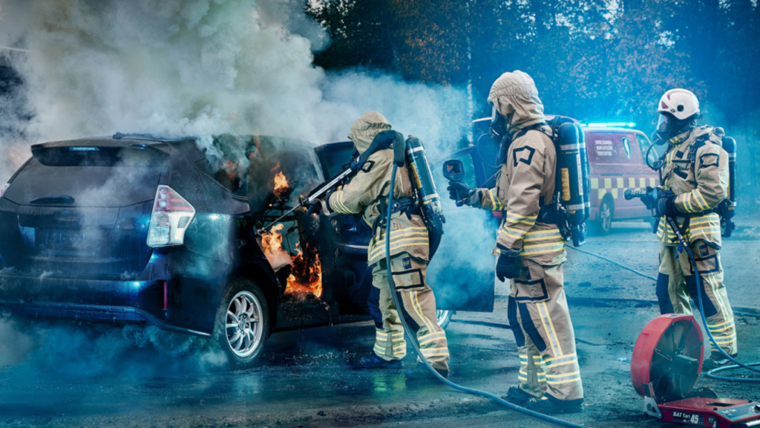

 22 Mar 2023

New revolutionary method tested extinguishes lithium-Ion EV fires in ten minutes with minimal water use